**AMERICAN INTERNATIONAL UNIVERSITY-BANGLADESH**

**Faculty of Science and Technology**



**Course Title: Data Communication**

**Lab Report-1**

|  |  |
| --- | --- |
| ***Submitted by:***  **Name: Shifat, Shadril Hassan**  **ID: 20-42451-1**  **Section: G**  **Program: BSc CSE**  **Semester: Spring 2021-2022**  **Date: 11 February, 2022** | ***Submitted to:***  **Course Teacher: Tanjil Amin** |

**Generate two sinusoids with different amplitudes, frequencies, and phases.

x1(t) = K1*cos(2π(E+F+5)t + J1), x2(t) = K2*cos(2π(C+D+5)t + J2)The value of the amplitudes are as follows: let K1 = A+B and K2 = G+H+2. For the phases, use J1 = D+G+20 (in degrees), and take J2 = 30º. When doing computations in Matlab, makesure to convert degrees to radians**.**

**Here,**

**ID:** 20-42451-1

**So,** A=2, B=0, C=4, D=2, E=4, F=5, G=1, H=1

**(a)** Make a plot of both signals on two separate figure windows, over a range of ‘t’ that will exhibit approximately 3 cycles. Make sure that you have enough samples per period of the wave to have a smooth signal in figure.

**MATLAB Code:**

A=2;

B=0;

C=4;

D=2;

E=4;

F=5;

G=1;

H=1;

K1=A+B;

K2=G+H+2;

J1=deg2rad(D+G+20); % converting degree to radian

J2=deg2rad(30);

% Generating time array for approx. 3 cycles

sampling_rate=1000;

sampling_interval=1/sampling_rate;

t=0:sampling_interval:3/10;

% For X1(t)

X1_t=K1*cos(2*pi*(E+F+5)*t+J1);

plot(t,X1_t,'b','linewidth',1.5);

%xlim([0 0.215]);

xlabel('time');

ylabel('amplitude');

title('sinusoidal signal, X1(t)');

% For X2(t)

figure;

X2_t=K2*cos(2*pi*(C+D+5)*t+J2);

plot(t,X2_t,'g','linewidth',1.5);

xlabel('time');

ylabel('amplitude');

title('sinusoidal signal, X2(t)');

**Output:**

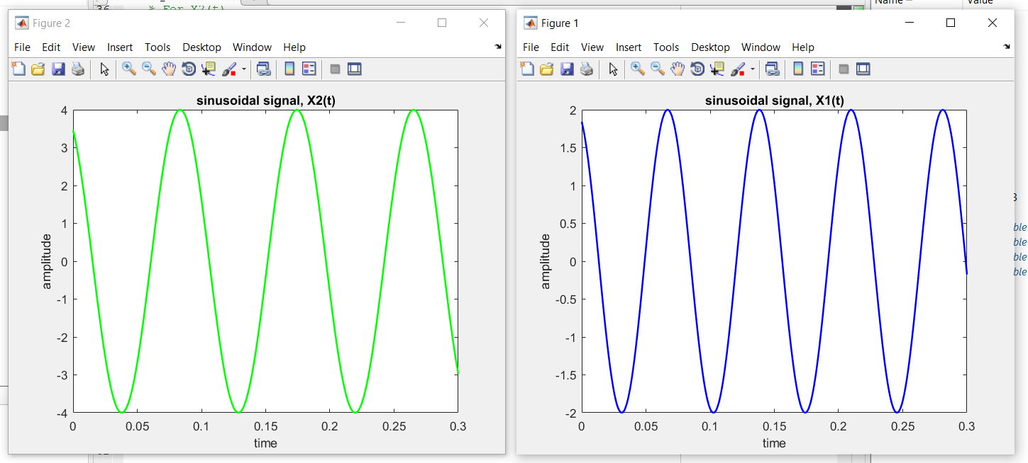

**(b)** Create a third sinusoid as the sum: x3(t) = x1(t) + x2(t). In Matlab this amounts to summing the vectors that hold the samples of each sinusoid. Make a plot of x3(t) over the same range of time as used in the previous two plots.

**MATLAB Code:**

% For X3(t)

X3_t=X1_t+X2_t;

plot(t,X3_t,'r','linewidth',1.5);

xlabel('time');

ylabel('amplitude');

title('sinusoidal signal, X3(t)=X1(t)+X2(t)');

**Output:**

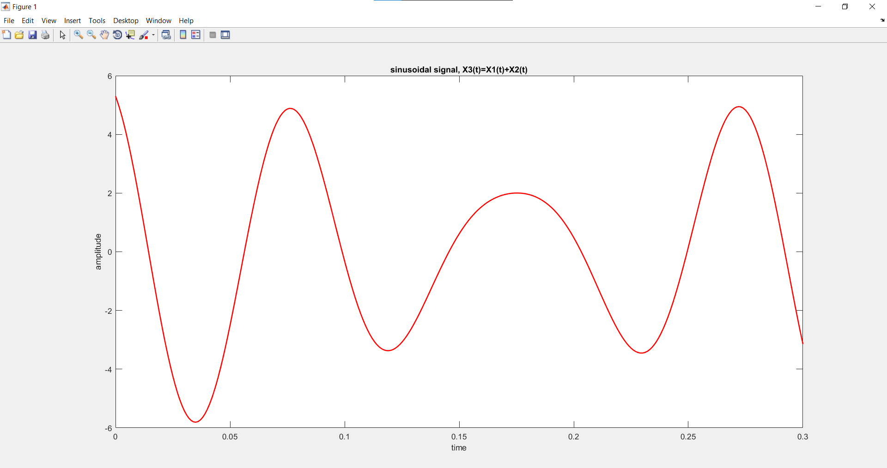

**(c)** Use subplot (3,1,1), subplot (3,1,2), and subplot (3,1,3) to make a three-panel subplot that puts all of three signals (x1(t), x2(t), and x3(t)) on the same window. See help subplot.

**MATLAB Code:**

subplot(3,1,1);

plot(t,X1_t,'b','linewidth',1.5);

xlabel('time');

ylabel('amplitude');

title('sinusoidal signal, X1(t)');

subplot(3,1,2);

plot(t,X2_t,'g','linewidth',1.5);

xlabel('time');

ylabel('amplitude');

title('sinusoidal signal, X2(t)');

subplot(3,1,3);

plot(t,X3_t,'r','linewidth',1.5);

xlabel('time');

ylabel('amplitude');

title('sinusoidal signal, X3(t)=X1(t)+X2(t)');

**Output:**

